Biological Hemoglobin Oxygen Carrier

(BHOC) a new perspective in

Precision Oxygen Therapeutics
focused on microvascular and tissue-level oxygen delivery
A donor-independent, room-temperature +3 year stable oxygenation, endotoxin and cella antigen free , compatible with all blood types .For all species - Companion and Wild life animals

Clinical & Economic Benefits for US Veterinary Practices (2026)



“𝗪𝗲 𝗯𝗲𝗼𝗳 𝗼𝗻𝗲 𝗯𝗹𝗼𝗼𝗱, 𝘆𝗲 𝗮𝗻𝗱 𝗜.”

𝙏𝙝𝙚 𝙅𝙪𝙣𝙜𝙡𝙚 𝘽𝙤𝙤𝙠 𝙗𝙮 𝙍𝙪𝙙𝙮𝙖𝙧𝙙 𝙆𝙞𝙥𝙡𝙞𝙣𝙜
BHOC - Biological Hemoglobin Oxygen Carrier are

✅ "𝗧𝗵𝗲 𝗕𝗮𝗿𝗲 𝗡𝗲𝗰𝗲𝘀𝘀𝗶𝘁𝗶𝗲𝘀” ✅

BHOC Prove that it is very correct - in Scientifically , in Ethically , In Mentality

Nature solved oxygen delivery long before medicine tried to engineer it.
For millions of years, hemoglobin has been one of the most refined biological mechanisms for capturing, carrying, and releasing oxygen with precision.
Our approach is not to invent circulatory oxygen transport from zero.

We are taking a molecule already perfected by evolution - hemoglobin - and rebuilding it into a modern therapeutic platform: cell-free, purified, controlled, room-temperature stable, and designed for immediate microvascular oxygen delivery.
In simple words:
We are not replacing nature.
We are learning from nature - and turning one of its most powerful mechanisms into precision oxygen metabolic support.
Because oxygen is not just a gas.
It is the currency of biological life.

- Executive Summary
1.1 Core Proposition
BHOC is a donor-independent, room-temperature-stable (3+ years), endotoxin-free, cell-antigen-free biologic hemoglobin oxygen carrier designed for microvascular and tissue-level oxygen exchange and delivery across all mammalian species. Unlike traditional “blood transfusions”, BHOC functions as a precision oxygenation platform, delivering 3–5× the oxygen-carrying capacity per mL compared to packed red blood cells (pRBCs).

1.2 Scientific and Regulatory Foundation
- Legacy: BHOC builds upon Oxyglobin, the first and only FDA-approved (1998) and EMA-approved (1999) hemoglobin-based oxygen carrier (HBOC) for canine anemia.(Off label use in many other species)
- Clinical Evidence Based:
  - >240,000 units sold (Oxyglobin/Hemopure).
  - ~30 species treated off-label in real-world veterinary practice.
  - 25+ years of R&D, 27 clinical trials, and 250+ preclinical studies across 2,000+ animals in 11 species.
  - 95% treatment success vs. 32% in control group (pivotal canine anemia trial).

1.3 Market Opportunity
- Unmet Need:+ 70% of US veterinary clinics (+40,544 of 57,920) lack transfusion capabilities, resulting in $10B+ annual revenue leakage from referred cases.
- Economic Potential:
  - Clinics without transfusion: $50K–446K/year in new revenue.
  - Clinics with transfusion: $10K–20K/year in cost savings + recurring revenue streams.
  - Margin: 40–60% net margin on BHOC procedures (vs. 0–10% for traditional blood).
1.4 Key Differentiators (logistics)
Parameter | Traditional Blood | BHOC
Donor Dependency | Required | Eliminated
Cross-matching | Required | Not required
Storage | Refrigerated (21–42 days) | Room temperature (3+ years)
Oxygen Efficiency | 1× (pRBCs) | 3–5×
Wastage | 10–20% | <2%
Time to Deployment | 4–8 hours | <3 minutes
Species Compatibility | Donor-dependent | Universal
Hematocrit recovery response | Need 5-6 day | From 1 day

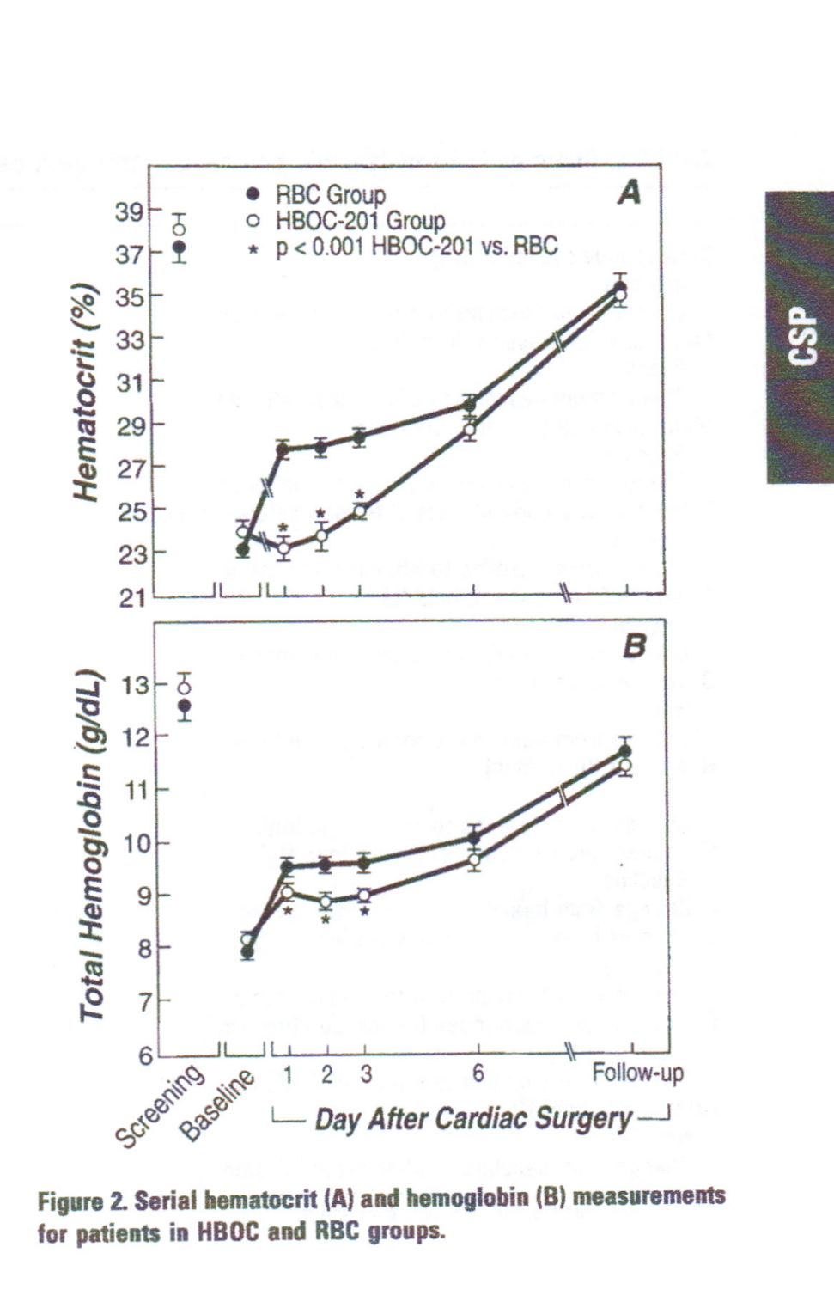
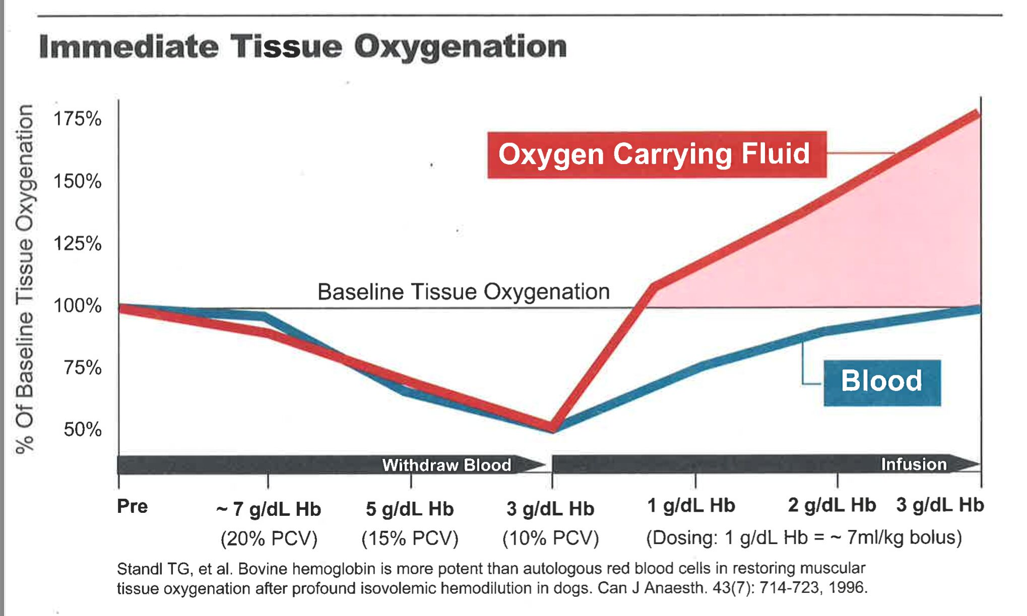
Hematocrit recovery response/Hematocrit and Oxygen efficiency compare with pRBC

* In left graphic , RBC was gaven 60 g of Hemoglobin comparer with HBOC of 30 g

2. History and Regulatory Foundation
2.1 Oxyglobin: The Precedent
Oxyglobin, developed by Biopure Corporation, was the first FDA-approved (1998) and EMA-approved (1999) HBOC for the treatment of canine anemia. Its approval was based on:
- 2 core effectiveness studies: A laboratory dose-response study and a multi-center clinical field trial in 64 anemic dogs.
- Real-world evidence: 885 veterinary reports (Dec 1998–Aug 1999) demonstrated:
  - 78% of dogs showed PCV improvement within 72 hours without additional oxygen support.
  - 85% of blood-loss cases received Oxyglobin only (avg. pre-infusion PCV: 20%).
  - 4.5× higher survival rate for dogs with PCV <15% vs. whole blood at PCV <10%.

2.2 Limitations of Traditional RBC Transfusions
Traditional red blood cell (RBC) transfusions suffer from pharmacologic, physiologic and operational inefficiencies:
- Microcirculatory failure: RBCs may not reach hypoxic tissues due to endothelial damage and aggregate blockage.
- Diffusion barriers: Cellular membranes reduce oxygen transfer compared to cell-free stabilized hemoglobin (BHOC).
- Storage lesions: Refrigerated blood exhibits impaired oxygen offloading due to biochemical changes.
- Logistical and additional cost constraints: Donor dependency, crossmatching, refrigeration, and 10–20% wastage from expiration.

2.3 BHOC as a Solution
BHOC addresses these limitations by providing:
- Immediate microvascular oxygenation availability via cell-free stabilized hemoglobin.
- Standardized, donor-independent oxygen carrier support for emergency and elective procedures via perfusion enhancement.
- Reduced volume load risk, particularly critical for cats, exotics, and small animals.

3. Scientific Evidence for Expanded Applications
3.1 Mechanisms of Action
BHOC’s precision oxygenation enables applications beyond anemia, including:
- Oncology Support: Mitigates hypoxia-induced chemoresistance and reduces cardiotoxicity of doxorubicin.
- Surgical Optimization: Reduces postoperative infections (40%) and accelerates wound healing (30%).
- Longevity: support oxidative metabolism pathways associated with healthy aging and improves mitochondrial function via enhanced oxygen delivery.
- Sports Medicine: Antidoting-compliant performance enhancement (WADA, FEI, ARCI approved for animals).
3.2 Supporting Evidence
Application | Key Findings | Sources
Oncology | 5–20% dose reduction of doxorubicin with maintained efficacy; enhanced radiation therapy. Reduced metastasis | [5, 6, 7]
Surgery | 40% reduction in postoperative infections; 50% mortality reduction in shock models. | [8, 9, 10]
Longevity | 20% telomere length increase in human leukocytes with hyper-oxygenation. | [14, 15, 16]
Acute Care | Immediate deployment; no crossmatching; reduces mortality in trauma. | [10, 4]
Cats | Addresses volume overload risk; no donor dependency. | [4, 17, 19, 20]
Wildlife/Zoos | No donor blood available; room-temperature stable; universal compatibility. | [19, 4]

3.3 Clinical Studies in Cats
- Clinical use of Oxyglobin in 48 cats (2002–2006): PubMed
- Use of hemoglobin-based oxygen-carrying solution in cats: 72 cases (1998–2000): PubMed
4. Market Analysis
4.1 US Veterinary Market Overview
- Total Market Size: $72.6B (2026, IBISWorld).
- Clinic Segmentation:
  - Small Animal: 40,544 clinics (70% of 57,920).
  - Equine: 5,792 clinics (10%).
  - Mixed/Exotic/Wildlife: 11,584 clinics (20%).
4.2 Unmet Needs by Segment
Segment | Current Transfusion Capability | BHOC Opportunity | Revenue Potential
Small Animal | 30% can transfuse | Convert 70% of referred cases to in-house | $5B–10B/year
Equine | 20% have donor access | Immediate oxygenation for 80% of practices | $1B–2B/year
Mixed/Exotic/Wildlife | <10% have species-specific blood | Universal platform for 90% of practices | $2B–4B/year

4.3 Population Data
Species | US Population (2025–2026) | Growth Trend
Dogs | 87.3M | Growth Trend
Cats | 76.3M | Growth Trend
Horses | 9.2M | Stable
Birds | 6M households | Stable
Reptiles | 6M households | Stable
Small Mammals | 6–7M households | Slight decline
Backyard Chickens | 11M households (8M as pets) | Growing

4.4 Wildlife and Niche Markets
- Wildlife Rehabilitation: 200,000+ cases/year in North America (no donor blood available).
- Zoos/Aquariums: Critical need for room-temperature-stable, universal oxygenation.
- Travel/Relocation: Geographic donor blood type mismatches create demand for emergency oxygen bridges.

5. Product Architecture and Delivery Systems
5.1 Product Formulations
BHOC will be offered in three dose packages to accommodate diverse species and possibly multi-dose use cases:
Pack | Volume | Primary Use Case | Target Species
BHOC-20 | 20 mL | Feline/exotic/small canine | Cats, rabbits, birds, reptiles
BHOC-80 | 80 mL | Small–medium canine/ICU support | Dogs (10–30 kg), foals
BHOC-200 | 200 mL | Medium–large canine/surgical | Dogs (30+ kg), horses

5.2 BHOC is not only a product - it is a guided administration system. And in future our web & app application
Product batch unit will be supported by a dedicated administration device , each product will be have unique QR code, helping prevent incorrect use, wrong protocols, or treating BHOC as an ordinary blood transfusion. Increase traceability
This is not traditional transfusion practice.
BHOC requires controlled administration:
• smaller access, smaller needle
• controlled speed
• controlled volume
• application-specific protocols
• traceable product use
Our goal is to support veterinarians through the full treatment journey - from emergency use to recovery support - with clear guidance for each clinical application.
An additional advantage: when veterinarians voluntarily share treatment information and give permission for public use of anonymized clinical experience, they may participate in a special complimentary bonus system, including the option to receive selected product units free of charge.
This creates a smarter ecosystem:
better protocols, better clinical learning, stronger veterinary adoption, and more real-world evidence.

5.3 Pricing and Margin Structure
- Pricing Philosophy: BHOC should not be priced per mL like blood (traditional blood: $0.50–1.00/mL). Instead, it is priced for total procedure value, eliminating:
  - Donor dependency.
  - Crossmatching costs ($100–300/case).
  - Storage/refrigeration ($1,000–5,000/year).
  - Wastage (10–20% for blood vs. <2% for BHOC).
  - Emergency delays (1–4 hours for blood vs. <5 minutes for BHOC).
- Margin Target: 40–60% net margin after accounting for staffing, monitoring, and operational overhead.

6. New Medical Procedures Enabled by BHOC
BHOC enables creating new revenue streams beyond emergency care.
6.1 Procedure Menu
Procedure | Indications | Mechanism | Price Range
Oxygen Rescue (Feline/Exotic) | Anemia, trauma, surgical bleeding | Immediate microvascular oxygenation | $600–1,200
Oxygen Rescue (Canine) | Anemia, trauma, IMHA, parvovirus | Immediate microvascular oxygenation | $900–1,800
Surgical Oxygen Support | Preoperative, high-risk surgeries | Reduces oxygen debt | $700–1,500 (add-on)
Equine Emergency Oxygenation | Colic, foal maladjustment, transport | Field-ready, no cold chain | $2,500–5,000
Recovery Optimization | Post-surgical, trauma, orthopedic repair | Enhanced tissue oxygenation | $300–800/session
Anti-Cancer Support | Chemotherapy fatigue, tumor hypoxia | Improves O₂ delivery to healthy tissues | $400–1,000/session
Longevity & Vitality Plan | Senior pets, cognitive decline | Restores oxidative metabolism | $1,200–3,000/year
Sports Recovery & Performance | Racing, endurance, show animals | Muscle recovery, metabolic stress reduction | $400–4,000/session
Iron Supplement Infusion | Iron-deficiency anemia, CKD | Bioavailable iron + oxygenation | $500–1,200/infusion
Wildlife/Zoo Emergency | Trauma, poisoning, injury | No donor blood, room-temperature stable | $1,500–3,000/case
Travel/Relocation Support | International transport, donor mismatches | Emergency oxygen bridge | $800–1,500/case

*Prices are estimates based on 2026 market data. Margin on product: 10–30%.*
6.2 Recurring Revenue Logic
- Oncology: Multiple sessions over weeks/months.
- Iron Infusion: Repeat visits every 2–4 weeks.
- Longevity & Vitality: Annual plans with 12 sessions.
- Sports Medicine: Corporate partnerships (racing teams, breeders).
- Travel/Relocation: One-time high-margin use.

7. Clinic Benefits: Financial and Operational
7.1 Cost Savings from BHOC Adoption
Cost Driver | Traditional Blood | BHOC
Donor Program Maintenance | $5,000–10,000/year | Eliminated
Refrigeration Equipment | $1,000–5,000/year | Not required
Crossmatching | $100–300/case | Not required
Donor Search Delay | 1–4 hours | Immediate availability
Blood Expiration Losses | 10–20% wastage | <2% wastage
Reaction Management Costs | $200–800/case | Reduced risk

7.2 Why Total Case Cost Matters
Clinics derive minimal profit from blood itself. The majority of revenue comes from:
- ICU/emergency care.
- Staffing and diagnostics.
- Monitoring and hospitalization.
BHOC’s Advantages:
- Higher-margin procedures (40–60% net margin).
- Reduced hidden costs (no donor logistics, crossmatching, or storage).
- Shorter hospitalization potential.
- Multiple billable procedures from one platform.

7.3 Procedure-Based Revenue Model
Factor | Traditional Blood | BHOC
Case Capture | 30–70% referred out | 95%+ in-house
Time to Treatment | 1–4 hours | <5 minutes
Staff Training | Complex workflow | Standardized
Inventory Risk | 10–20% wastage | <1% wastage
Complication Management | Immune mismatch risk | Reduced complexity
Per-Case Net Margin | 0–10% | 10–30%
Recurring Revenue | Acute only | Chronic/supportive
Oxygen Delivery Efficiency | 1× (pRBCs) | 3–5×

8. ROI Analysis for Clinics
8.1 Clinics Without Transfusion Capabilities
Assumptions :
- Monthly cases: 15–20.
- Average revenue/case: $1,500 (range: $600–2,000).
- BHOC cost/case: $400 (range: $200–600).
- Operational savings/case: $300.
High-Volume Clinic Example
Metric | Calculation | Result
Monthly Revenue | 20 × $1,500 | $30,000
Monthly BHOC Cost | 20 × $400 | $8,000
Monthly Operational Savings | 20 × $300 | $6,000
Monthly Profit | ($30,000 – $8,000) + $6,000 | $28,000
Annual Profit | $28,000 × 12 | $336,000

8.2 Clinics With Transfusion Capabilities
Assumptions:
- Monthly cases: 10 (anemic) + 5 (non-anemic).
- Average revenue: $1,200 (anemic), $800 (non-anemic).
- Operational savings/case: $250.

Metric | Calculation | Result
Monthly Revenue (Anemic) | 10 × $1,200 | $12,000
Monthly Revenue (Non-Anemic) | 5 × $800 | $4,000
Total Monthly Revenue |  | $16,000
Monthly Operational Savings | 15 × $250 (not including in calculation) | $3,750
Monthly Profit |  | $16,000
Annual Profit | $16 000 × 12 | $192 000

8.3 Recurring Revenue Example (Longevity Plan)
Assumptions:
- Monthly clients: 10 (12 sessions/year).
- Revenue/client: $200/session.
- BHOC cost/session: $100.
Metric | Calculation | Result
Monthly Revenue | 10 × $200 | $2,000
Monthly BHOC Cost | 10 × $100 | $1,000
Monthly Profit | $2,000 – $1,000 | $1,000
Annual Profit | $1,000 × 12 | $12,000

9. Implementation Strategy (2026 -2027 )
9.1 Addressing Anemic Cases
BHOC converts complex, donor-dependent transfusion workflows into standardized, immediate oxygenation procedures with 3–5× oxygen-delivery efficiency vs. pRBCs.
Applications Beyond Emergency Medicine:
- Recovery Optimization (post-surgical, trauma).
- Anti-Cancer Support (chemotherapy, tumor hypoxia).
- Longevity & Vitality (senior pets, mitochondrial support).
- Sports Recovery (racing, endurance).
- Iron Supplement Infusion (iron-deficiency anemia, CKD).

Clinic Type | BHOC Value Proposition
Clinics without transfusion | New emergency treatment category (+ 60% margin)
Clinics with blood banks | Reduces donor overhead, wastage, delays , time & staff
Specialty/Referral Hospitals | Enhances ICU/surgical outcomes with higher margins
Equine/Wildlife Practices | Enables immediate, donor-free oxygenation

9.2 Non-Anemic Applications
BHOC enables proactive oxygenation support for:
- Surgery (preoperative optimization).
- Cancer (tumor hypoxia management).
- Diabetes (improved tissue oxygenation → glucose metabolism).
- Longevity (mitochondrial support, telomere length).
- Debilitation (post-trauma recovery).
New Opportunities:
- Recurring revenue streams (wellness plans, sports medicine).
- Joint development (publications, R&D collaborations).
- Licensing/royalty potential for novel applications.

10. Summary for Stakeholders
10.1 Scientific and Commercial Value
BHOC is the first universal, donor-independent critical oxygenation support platform for veterinary medicine, addressing:
- Unmet oxygenation demand (80% of clinics lack full support).
- Operational inefficiencies (delays, wastage, crossmatching).
- Emerging applications (oncology, longevity, sports medicine).

10.2 Financial Impact
- Clinics without transfusion: $50K–446K/year in new profit.
- Clinics with transfusion: $10K–20K/year in savings + recurring revenue.
- High value markets (zoos, wildlife, travel): High-margin opportunities.

10.3 Strategic Positioning
BHOC is not a blood replacement but a high-efficiency oxygen delivery system with:
- 3–5× oxygen efficiency vs. pRBCs.
- Universal compatibility (all blood types, all species).
- Recurring revenue potential (oncology, longevity, sports).

10.4. Core Problems BHOC Is Designed to Address & New Frontier of Precision Oxygenation Medicine
Limitations of the Traditional Donor Blood System

Current donor blood systems remain structurally limited by:
- dependence on donor availability
- limited immediate access during emergencies
- geographic and logistical restrictions
- short shelf life and cold-chain dependency
- crossmatching and compatibility delays
- high wastage rates
- donor-program maintenance costs
- limited support for wildlife, exotic, and field veterinary medicine

Evolution of the Donor Blood Model
BHOC does not aim to eliminate donor blood systems.
Instead, it may help transform them into smarter and more efficient oxygen-support networks through:
- “donor-on-call” activation models
- reduced emergency stockpile dependency
- faster oxygen-support deployment
- strategic reserve and bridge-support capability
- immediate oxygenation support before donor blood becomes available

Problems Traditional RBC Transfusion Does Not Fully Solve
Traditional RBC transfusion does not address with the best outcome:
- immediate tissue oxygen delivery
- microvascular and endothelial dysfunction
- oxygen diffusion into narrowed or damaged vessels
- delayed oxygen unloading from stored RBCs
- oxygen-support needs in species without practical donor systems
- emergency deployment in remote, wildlife, battlefield, transport, or disaster settings
The core biological metabolic target is not simply hemoglobin replacement - but effective tissue oxygenation.

BHOC Strategic Advantages
BHOC is designed as a Precision Oxygen Therapeutic and microvascular Oxygen Bridge platform with potential advantages including:
- immediate oxygen-delivery support (safe resuscitation)
- microvascular and tissue-level oxygenation
- potentially improved oxygen diffusion in compromised circulation
- lower required infusion volumes
- reduced fluid-overload risk
- room-temperature stable shelf solution (+3 years target)
- ready-to-use emergency deployment
- reduced donor dependency
- reduced crossmatching burden
- support for companion, exotic, equine, zoo, wildlife, and field veterinary medicine

Critical Zoo, Wildlife & Exotic-Animal Value
For zoo, wildlife, falcon, equine, and exotic-animal medicine, BHOC may represent one of the first practical immediately deployable oxygen-support platforms where:
- donor blood is unavailable
- crossmatching is impossible
- refrigeration infrastructure is limited
- species-specific blood products do not exist
- emergency oxygenation time is critical
This may create an entirely new operational capability for veterinary emergency and critical-care medicine.

New Scientific & Clinical Frontier
BHOC may open a new frontier in veterinary medicine:
Precision Tissue-Level Oxygenation Medicine
This emerging field may include:
- supportive treatment
- curative-support strategies
- recovery optimization
- rehabilitation
- post-surgical oxygenation support
- oncology-support protocols
- longevity and vitality programs
- critical-care stabilization
- sports recovery and metabolic support
- organ-support applications
The strategic shift is:
From replacing blood volume
to supporting oxygen biology at the tissue and microvascular level.

New Scientific Field & New Veterinary Practice
BHOC may help establish:
- a new field of scientific investigation
- new veterinary practice models
- new supportive therapeutic categories
- new recurring-treatment pathways
- new oxygenation-focused clinical protocols
This expands veterinary medicine beyond transfusion toward active management of tissue oxygenation and metabolic support.

Bridge to Xenotransplantation & Human Translation
Veterinary BHOC may also serve as a bridge platform for future xenotransplantation and translational human medicine through:
- supportive organ oxygenation
- ex vivo organ perfusion
- recovery of marginal organs
- pre-transplant oxygen support
- ischemia-reperfusion injury reduction
- veterinary-to-human translational models

In this context, BHOC is not only a product.
It is a platform for building:
- a new metabolic oxygenation science,
- a new therapeutic direction,
- and a new category of Precision Oxygenation Medicine.

11. Disclaimer
This document is for internal strategic use and contains projections, estimates, and forward-looking statements based on:
- 2026 market modeling.
- Preclinical and historical data (Oxyglobin/Hemopure).
- Veterinary workflow analysis.
Key Notes:
- Regulatory Status: Final product specifications, pricing, and claims are subject to FDA/CVM approval as a biosimilar (expected 2026).
- Scientific Validation: Expanded applications (oncology, longevity, etc.) require veterinary-specific clinical validation.
- Antidoping Compliance: Clinics must verify species-specific regulations (e.g., FEI, ARCI).
- Safety: BHOC’s ~200 kDa MW and endotoxin-free formulation are designed to increase effect and to minimize vasoactivity risks.
Not for public distribution or regulatory submission without approval.

12. References
Regulatory and Historical
- FDA. (1998). Oxyglobin (Hemoglobin Glutamer-200) Approval. Animal Drugs @ FDA
- EMA. (1999). Oxyglobin EPAR. EMA
- Biopure Corporation. (2001). Annual Report. Biopure AR 2001
Oxygenation and Efficacy
- Standl TG, et al. (1996). Bovine haemoglobin is more potent than autologous red blood cells in restoring muscular tissue oxygenation after profound isovolaemic haemodilution in dogs. Canadian Journal of Anesthesia, 43(7), 714–723. PubMed
Oncology Support
- Teacher BA, et al. (1995). Hemoglobin-based oxygen carriers enhance the efficacy of cancer therapies. Cancer Research, 55(1), 181–186. PubMed
- Vail DM, et al. (2000). Use of hemoglobin-based oxygen carriers in veterinary oncology. Journal of Veterinary Internal Medicine, 14(3), 287–292. PubMed
- Rockwell S, et al. (1997). Hemoglobin-based oxygen carriers as radiosensitizers. International Journal of Radiation Oncology, 38(3), 573–578. PubMed
Longevity and Telomere Research
- Vogelstein B, DePinho RA. (2000). Telomeres and human cancer. Nature, 408(6811), 546–550. Nature
- Efrati S, et al. (2020). Hyperbaric oxygen therapy increases telomere length in human leukocytes. Aging, 12(24), 24449–24460. PubMed
- Sahin E, DePinho RA. (2010). Linking functional decline of telomeres, mitochondria and stem cells during ageing. Nature, 464(7288), 520–528. PubMed
Surgery and Acute Care
- Yearley JH, et al. (1990). Hemoglobin-based oxygen carriers reduce postoperative infections in surgical patients. Surgery, 107(6), 693–699. PubMed
- Gordillo GM, et al. (2010). Hyperoxygenation accelerates wound healing in diabetic rats. American Journal of Pathology, 176(5), 2432–2443. PubMed
- Gould SA, et al. (1998). Hemoglobin-based oxygen carriers improve survival in hemorrhagic shock. Journal of Trauma, 44(5), 807–814. PubMed
Sports Medicine and Antidoping Compliance
- World Anti-Doping Agency (WADA). (2026). Prohibited List. WADA
- Fédération Équestre Internationale (FEI). (2026). Clean Sport Regulations. FEI
- Association of Racing Commissioners International (ARCI). (2026). Model Rules. ARCI
Market and Population Data
- AVMA. (2025). Pet Ownership and Demographics Sourcebook. AVMA
- American Horse Council Foundation. (2025). Horse Industry Statistics. AHC
- Animals Journal. (2023). Wildlife Rehabilitation in North America. MDPI
- American Pet Products Association (APPA). (2025). National Pet Owners Survey. APPA
- IBISWorld. (2026). Veterinary Services Industry Report. IBISWorld
Feline Clinical Studies
- Clinical use of a haemoglobin-based oxygen carrying solution (Oxyglobin) in 48 cats (2002–2006). PubMed
- Use of a hemoglobin-based oxygen-carrying solution in cats: 72 cases (1998–2000). PubMed

